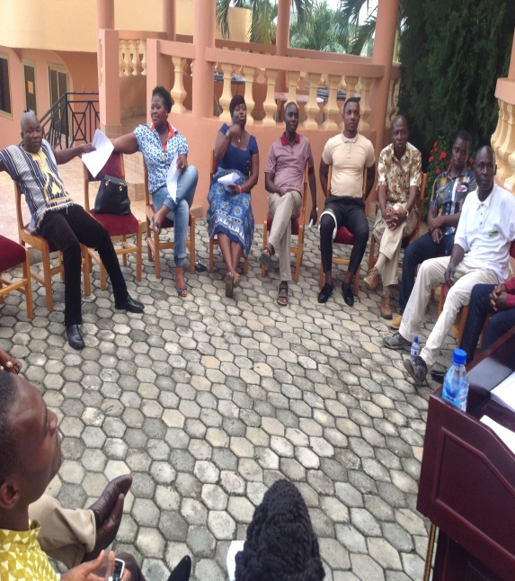**April 25th**

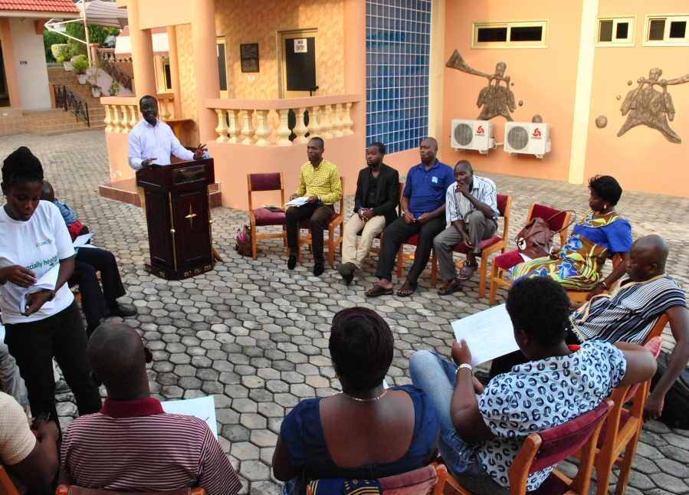 Senior and Junior Staff get treated to an expert talk on personal financial management.

1

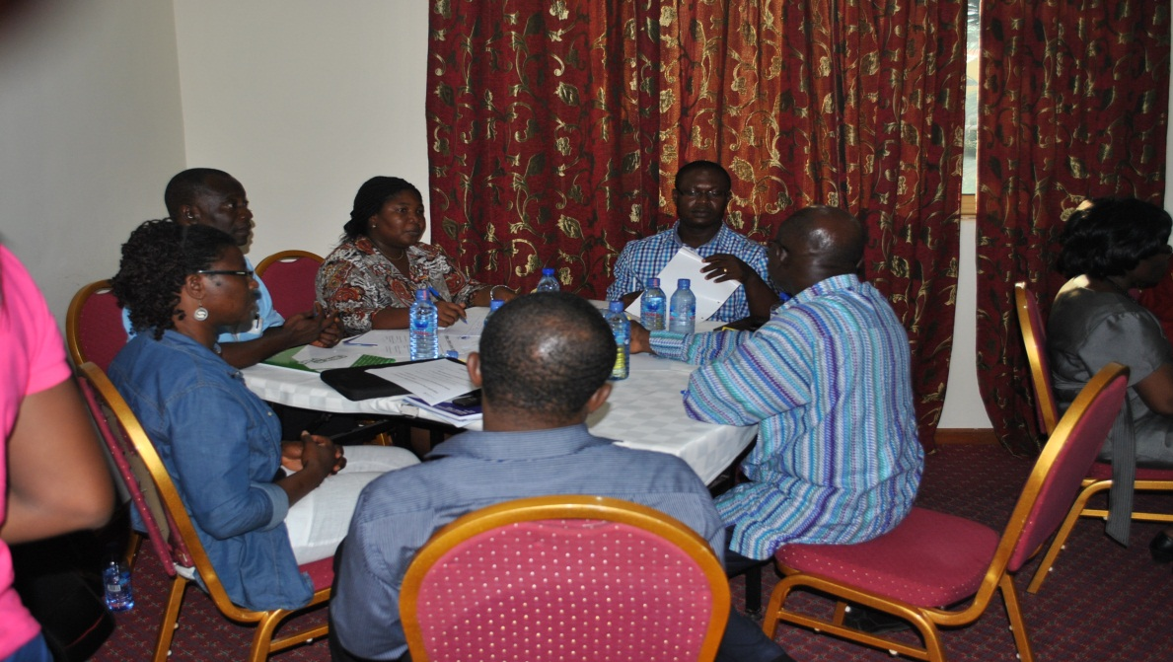

Group work - Senior Members engage in some brainstor-ming

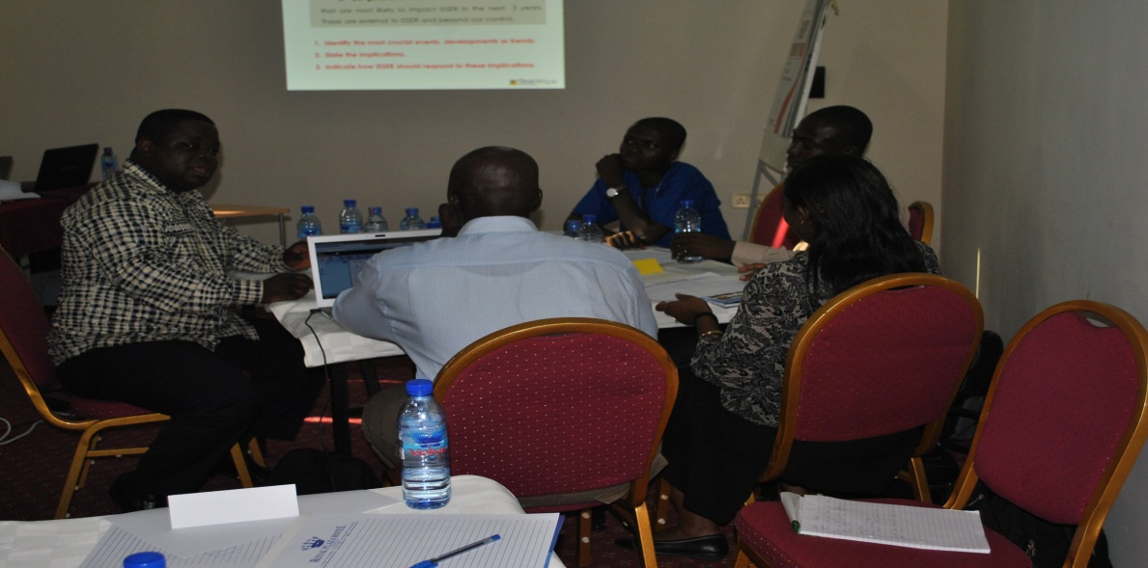

**April 26th**

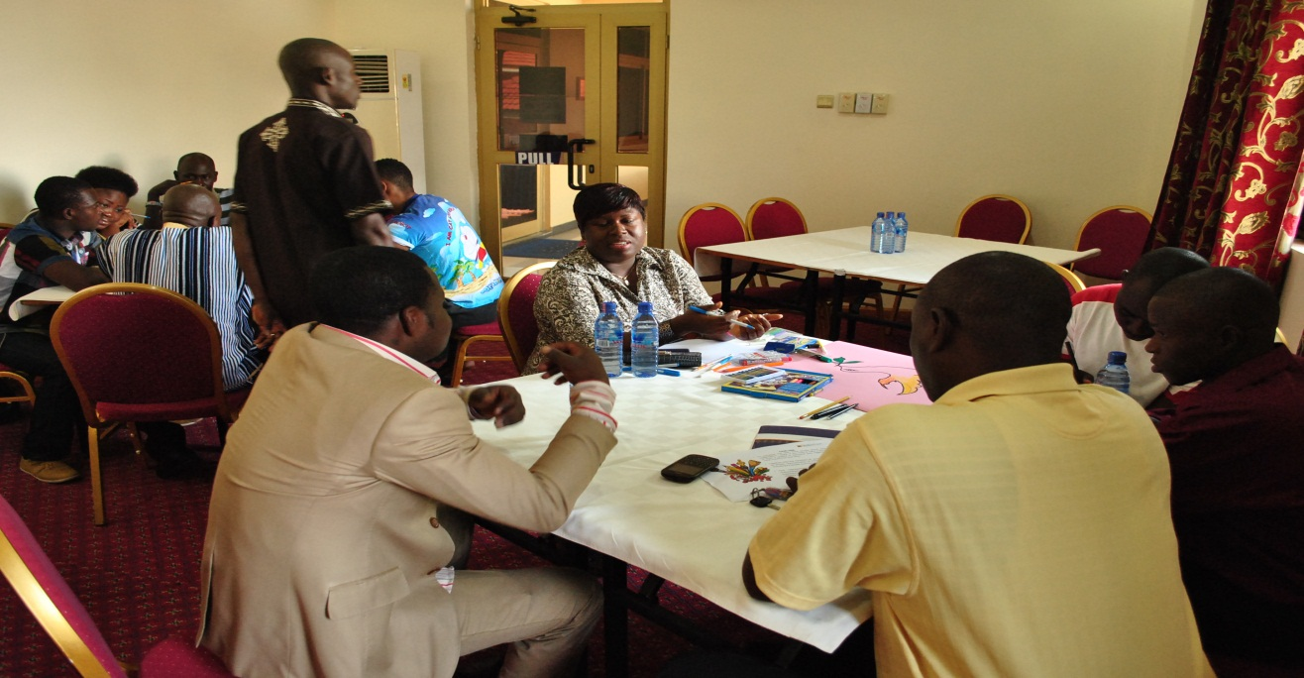

1: Group activity for Junior and Senior Staff.

2 & 3: Team leads present group work

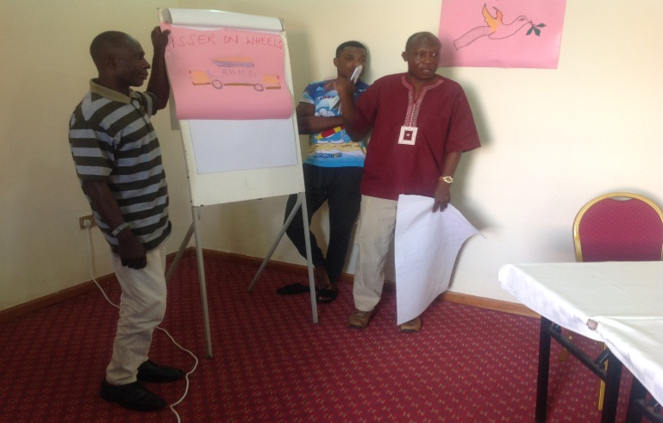 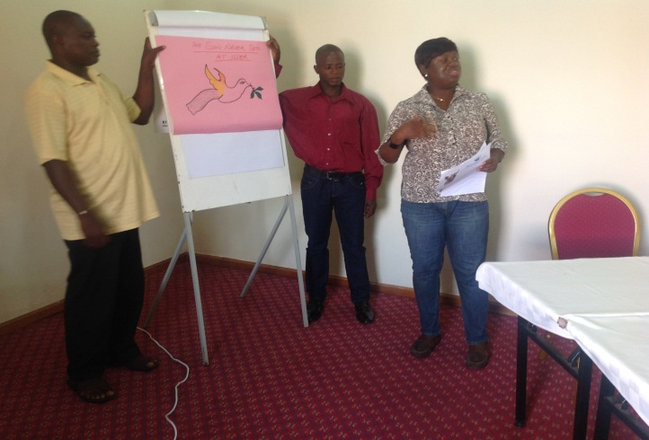

Thoughts, ideas on paper. Senior Members’ group activity.

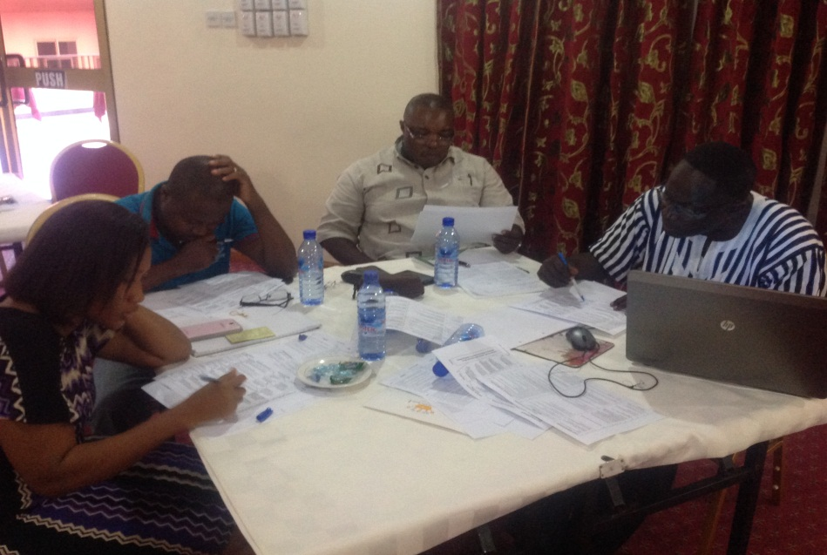 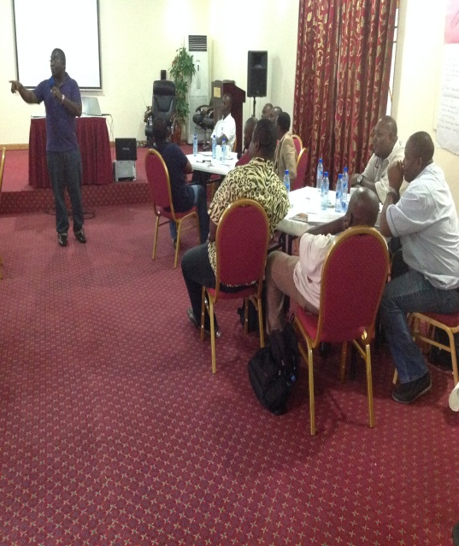

Bringing it all together. Members look up posters of ideas put up by colleagues …

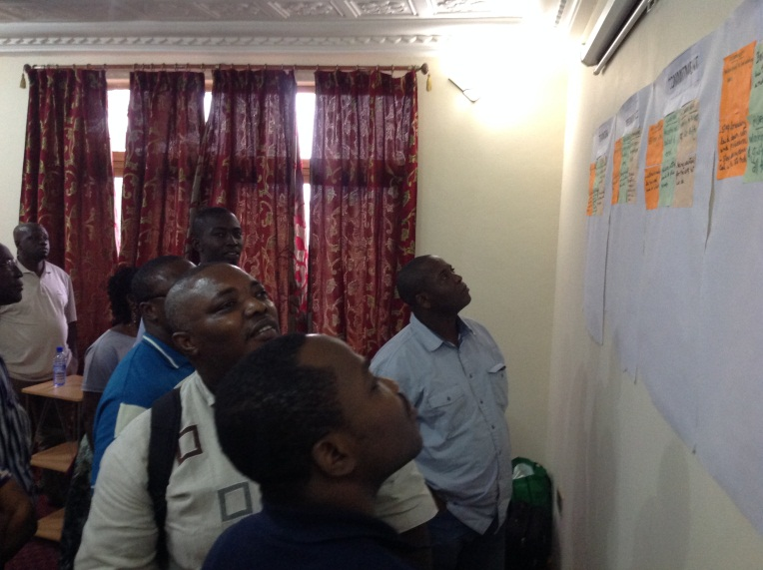 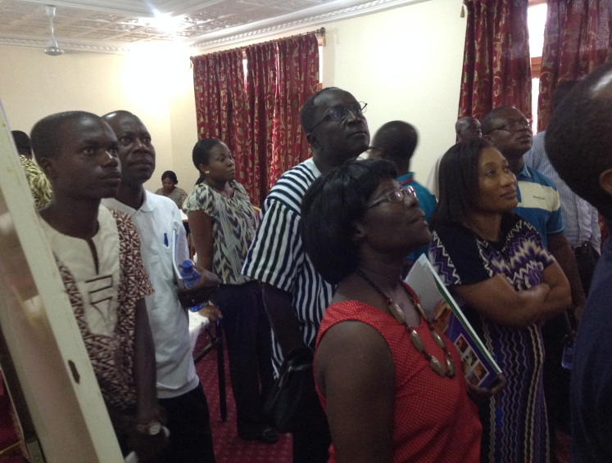

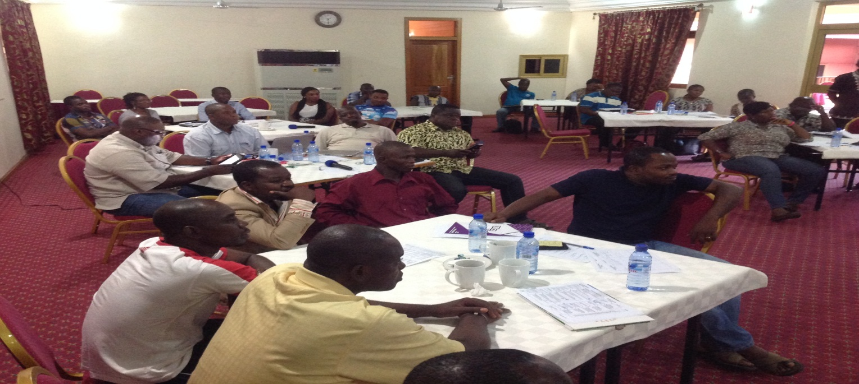

All staff get together finally

Junior & Senior Staff team leads make presentations

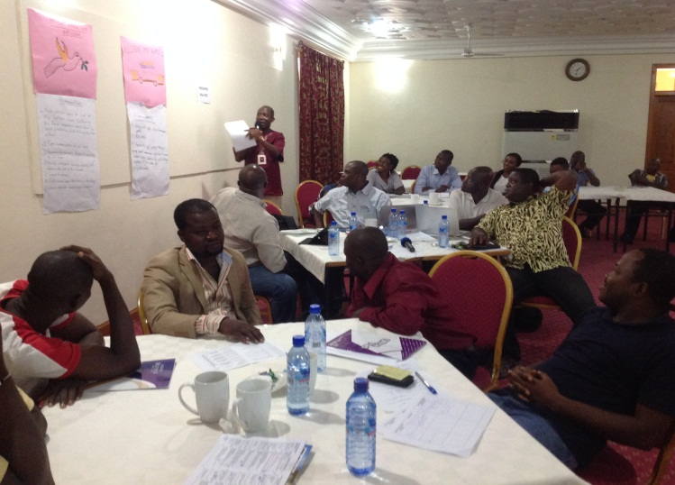 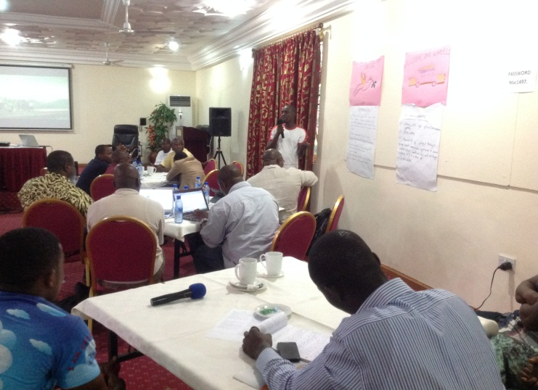

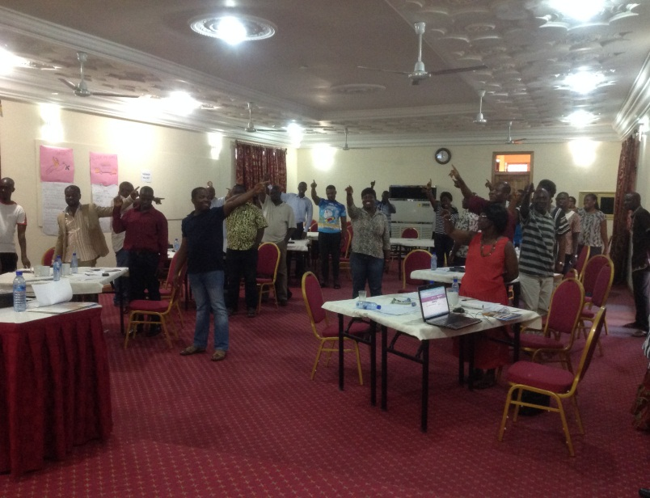 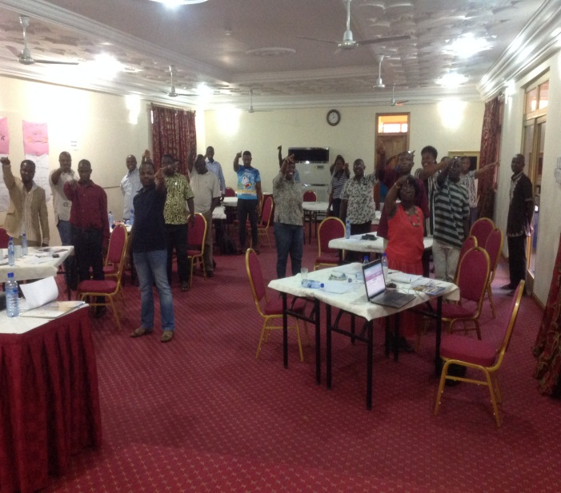

chaos, chaos when the gathering was asked to close eyes and point to the north east (or so)

Close eyes and point to the north east or so close eyes and point to the north east

Of course we got it right when we had to do it again, with eyes open this time. Fun!

Active participation as members tabled quality ideas

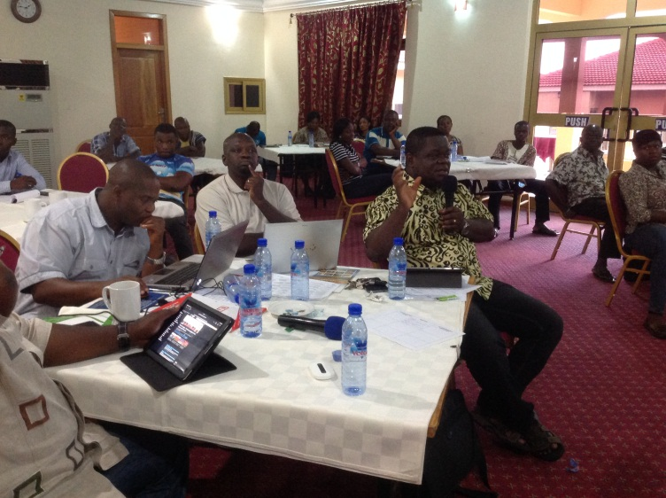 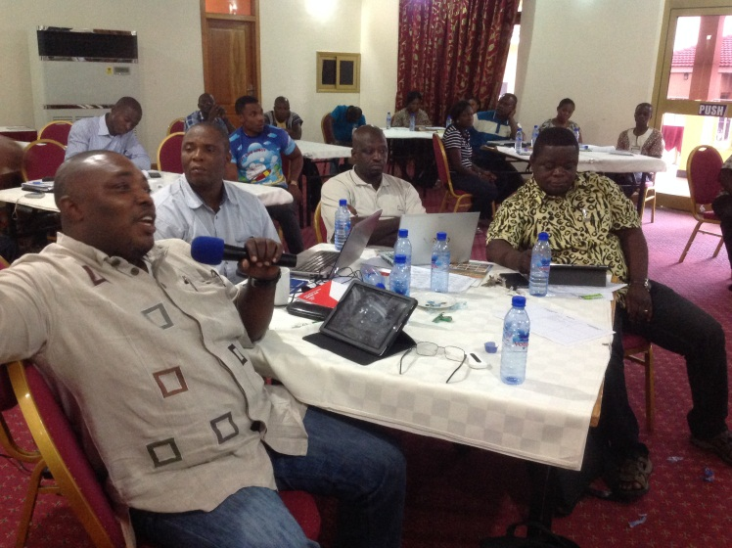

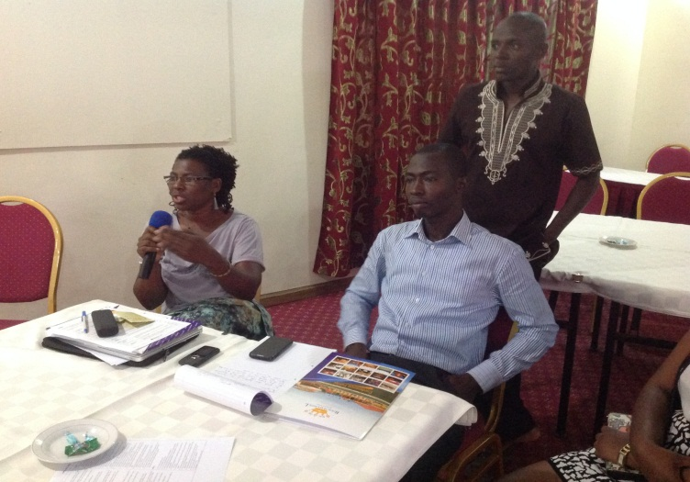 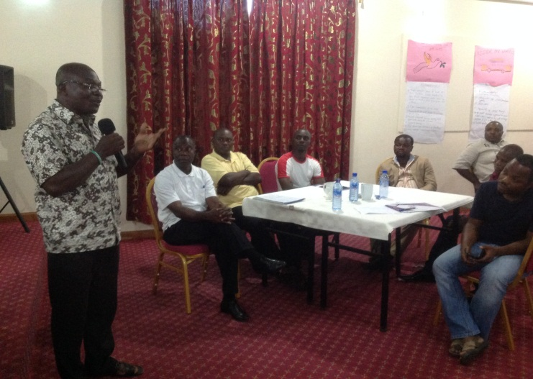

Director shares his thoughts

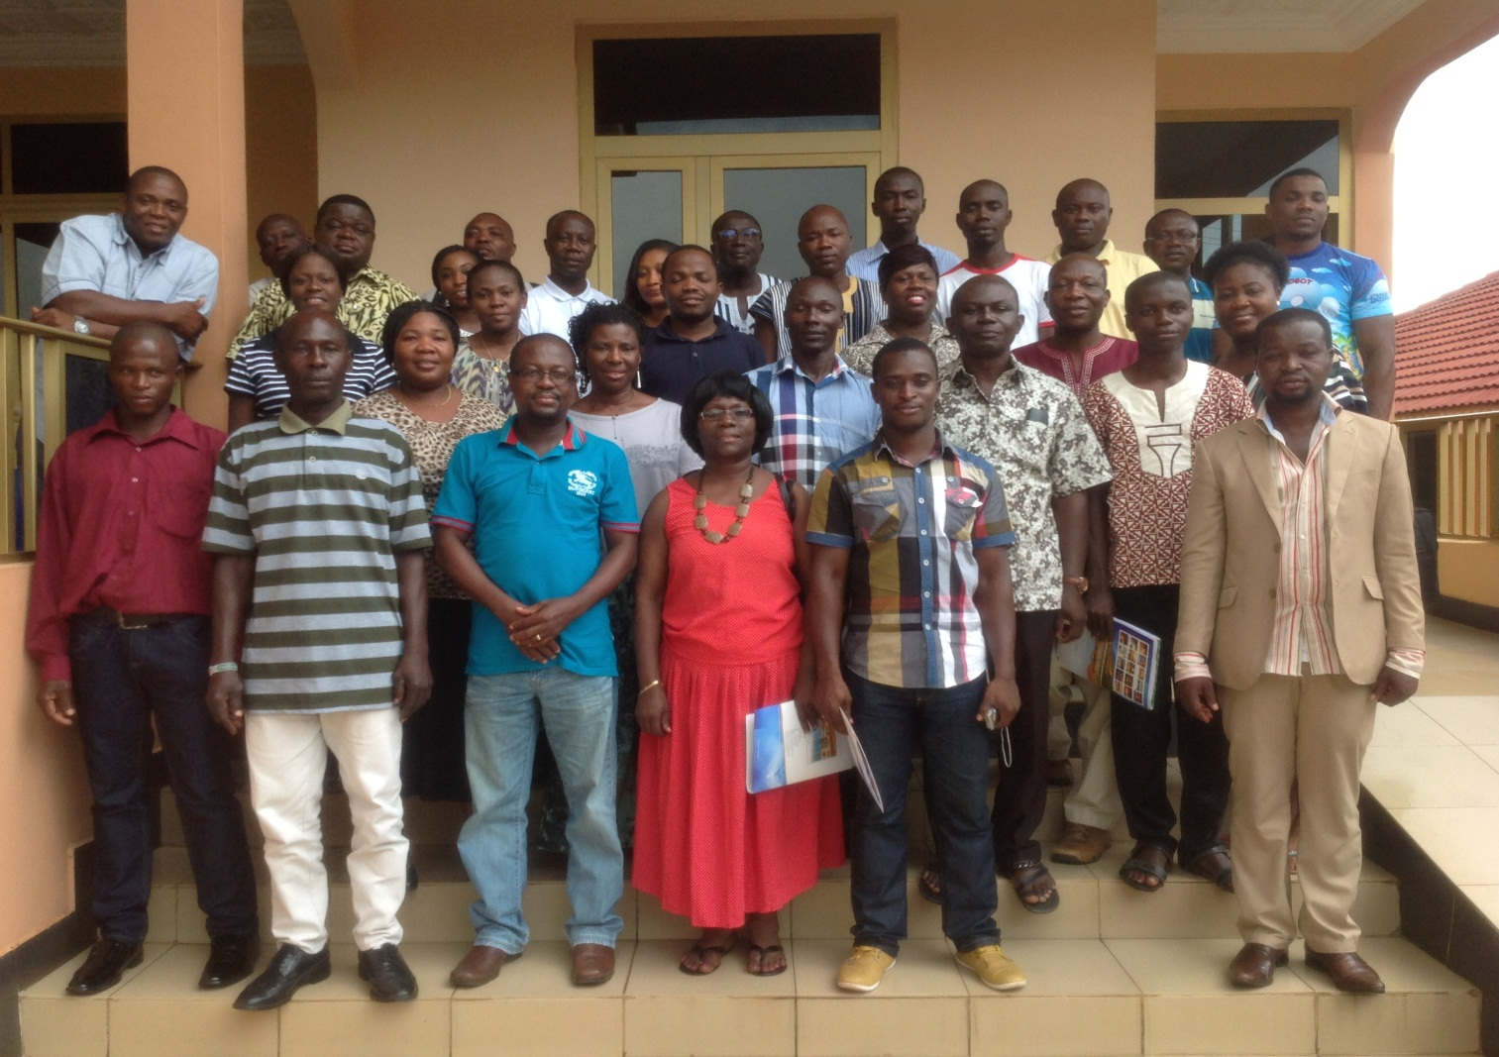

Staff take a group picture at the end of a very successful retreat