The Researcher
The Bi-Annual Newsletter of ISSER Issue No. 1 January – June 2014

Draft 1

In this issue
A Moment of inspiration
- Make it happen!
News from the Field
- The EGC-ISSER Socioeconomic Panel Survey

Feature article
- Where would you rather pursue your doctoral degree, home or abroad?

Staff Zone (the S-Zone)
- Why do strategic plans fail?
- Images from Koforidua 2014

Events
- International Gender Analysis Training Workshop (in pictures)

Editorial Board

Editorial
Your official newsletter, the researcher is back!
The new researcher has exciting new features, designed with your absolute satisfaction in mind. It is electronic, so that news and information is delivered to you on time. Save the researcher on your favourite mobile device and read it as you go!
It is colourful, concise and smart, so that you have a pleasurable reading.
The new researcher will have three main (constant) segments – news from the field, featuring news and information on on-going projects; a feature article, which will cover a wide range of themes and a special segment labeled the staff zone or the S-Zone, for short. In the S-Zone, dedicated to staff but no less useful to our wider publics, we get interactive and talk exclusively about the issues that matter most to our cherished staff. We will cover a wide range of intriguing topics spanning staff news, tit bits (tips on finances, health, family life. We will also feature funny reads, announcements, useful lessons from here and there, you name it!). Perhaps more importantly, questions and concerns of staff will be addressed in the S-zone. Staff are very much encouraged to get talking with us - views, comments and questions are definitely welcome. Be assured that we will take time to address them all.
A fourth segment, dedicated to ISSER events, will be included as and when necessary, to bring you sights and exciting stories from ISSER events as they happen.
And now, Akwaaba, welcome to your new and exciting researcher bi-annual newsletter.
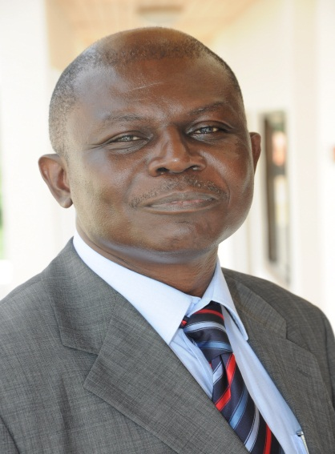
In this edition, covering the period January to June 2014, we get started with a moment of inspiration from the Director’s desk. In field news, we bring you up-to-date information on the EGC-ISSER Socioeconomic Panel Survey. For our feature, we will, in what will be the first of a two-part series, bring you interesting stories on the ISSER PhD programme in Development Studies, run under Ghanaian-German Division for Development Studies. We bring you revealing insights into how ISSER, collaborating with the Centre for Development (ZEF), Germany, is contributing to shaping the next generation of leaders through its top-of-the-line PhD programme.
ISSER held a staff retreat from April 25 to 26, at Koforidua, to develop the next five-year strategic plan for the Institute. In the S-Zone, your researcher will bring you an exciting picture story of this event as well as tips on why strategic plans fail – so that we will be informed and work to avoid them. Turn to the S-Zone for all the juicy details.
In our events segment, we bring you reports and images from the five-day International Gender Analysis Training Workshop, held at ISSER in April, 2014. Welcome aboard!!

A Pause for Inspiration

Make it happen!
I bring you sincere greetings. I am excited, as I believe you are, about the return of our bi-newsletter, the researcher. I am even more excited about the additional opportunity it presents us to interact and exchange information and advice.

In this first edition of ‘a moment of inspiration’ I would like to encourage us all to take charge of the future, as individuals and collectively as an institute – especially as we prepare to launch a new strategic plan.

There is a famous quote by John F. Kennedy (a former President of the United States of America) that says: “Things don’t happen, they are made to happen.” How true this is. I strongly believe that great things do not happen by chance; it takes planning, commitment and work.

Dear colleagues, our greatest dreams and hopes for the future are really achievable, if only we can commit ourselves to work at it. If you desire it, then plan for it, commit to the plan and work hard at it. Our greatness as individuals is very much linked to our greatness as a collective institution. I therefore encourage you to strive to be the best, or at least count among the best, in all you do. Whether you are a support staff, a team leader or a team member, make the quest for excellence your habit.

The success of our strategic vision is dependent on the individual inputs we make every day. The vision is ours. Let’s make it a success. Thank you.

News from the field

The EGC-ISSER Socioeconomic Panel Survey – Promoting Development through Research

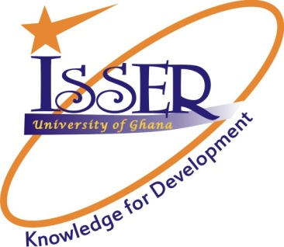
The Institute of Statistical Social and Economic Research, University of Ghana in collaboration with the Economic Growth Center (EGC) of Yale University is conducting a nation-wide panel survey, with the objective to provide a scientific framework for a wide range of potential studies of the medium- and long-term changes that are taking place during the process of development.

The survey, principally funded by the EGC, designed by both the EGC and ISSER, and carried out and supervised by ISSER, is meant to remedy a major constraint on the understanding of development in low-income countries – that is the absence of detailed, multi-level and long-term scientific data that follows individuals over time and describes both the natural and built environment in which the individuals reside.

According to Professor Felix Asante, Director of ISSER, research knowledge can drive socio-economic development and improve human well-being, a fact that reinforces ISSER’s unwavering focus on research, to inform Ghanaian and international development policy makers and practitioners about the socio-economic status of Ghanaians and the opportunities for improvement. He said a key priority of ISSER is to build capacity for social science research in Ghana and beyond. The Institute in fulfilment of this objective undertakes many activities for the benefit of various groups, organisations and the nation at large.

He said the current nationwide panel survey will make available a rich information resource that will serve not only the research needs of ISSER and its partner institutions but also students and researchers of the University of Ghana as well as interested parties from other universities and institutions. “The nation-wide socio-economic panel survey is just another instrument ISSER is using to promote and facilitate social science research for development,” he said.

Dr. Robert Osei, a lead investigator, shedding more light on the project explained that currently, most data collection efforts are short-term - carried out at one point in time; are limited in scope - collecting information on only a few aspects of the lives of the persons in the study. He said even when there are multiple rounds of data collection, individuals who leave the study area are dropped. This means that the most mobile people are not included in existing surveys and studies, thus considerably affecting accuracy of data.
He added that the design of the ECG-ISSER panel survey aims to mitigate the selectivity associated with migration in assessing socio-economic mobility by tracking migrated individuals and households.
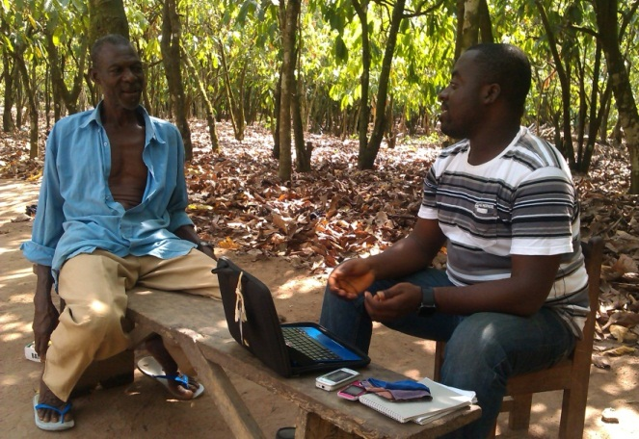
Dr. Clement Adamba, project coordinator, explaining the last point further said individuals and households who were interviewed during wave 1 but had since moved to different households or locations are tracked to their current new locations in order for them to be interviewed for wave 2. “This additional feature not only helps reduce attrition, a major constraint of panel surveys, but also adds a new richness to information collected as it allows for comparisons to be made between different locations and the impact they have on the lives of inhabitants”, added.
Enumerator conduction interview using the computer administered personal interview (CAPI)

The EGC-ISSER Socioeconomic Panel Survey will extend for at least 15 years, with a planned re-surveying interval of three years.

Lead investigators for the survey are Dr. Robert Osei and Dr. Isaac Osei Akoto of ISSER and Prof. Christopher Udry of the EGC.

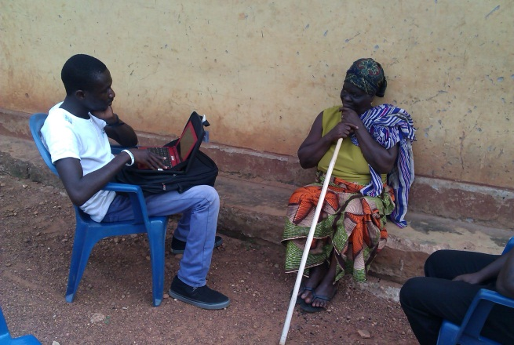
Enumerator conduction interview using the computer administered personal interview (CAPI)

Facts at a glance:
- The EGC-ISSER socioeconomic panel survey provides regionally representative data for the 10 regions of Ghana.
- Information gathered from the survey will assist decision makers in the formulation of economic and social policies to:
- identify target groups for government assistance
- construct models to stimulate the impact on individual groups of the various policy options and to analyze the impact of decisions that have already been implemented
- access the economic situation on living conditions of households
- Provide benchmark data for district assemblies.
For more information on the EGC-ISSER Socioeconomic Panel Survey, please visit http://isser.edu.gh/panelsurvey/EGC_ISSER.html.

Feature article

Where would rather you pursue your doctoral degree?
Home or abroad?

Many are those who will let go their imagination on a wild and loose run, at this question. The mind will join in the action, calculating and weighing options, advantages, pros and cons of choosing one place over the other. But for Dr. George Domfe, a fellow and lecturer of the Centre for Social Policy Study, University of Ghana, the decision to pursue his doctorate degree at the Ghanaian-German Division for Development Studies (GGDDS) of the Institute of Statistical Social and Economic Research (ISSER), University of Ghana, was sure, instant and came with no second thoughts.
According to Dr. George Domfe, who enrolled at the Ghanaian-German Division for Development Studies (GGDDS) at ISSER in 2010 and successfully graduated in 2013, with a PhD in Development Studies, the programme came to him as a rare and timely opportunity, one he is happy to have seized. He describes the programme as “one of the best around.”
In an interview with the researcher, Dr. Domfe said he joined ISSER as a Principal Research Assistant with a Master of Philosophy (Mphil) in Economics. Prior to this, he had worked with the Ghana Education Service for 10 years as a professional teacher and had long had a burning desire to develop a career in academia. Opportunities for self-development were however long in coming. “But my plans and hopes started falling into place when I joined ISSER as a principal research assistant,” he said.
According to him, his job gave him opportunity to work with various research fellows of the Institute on one project after another and he was totally awed by the professionalism and commitment to quality – which characterized work output at the Institute. At a point, according to Dr. Domfe, he realized he wanted to tap into all the competence and experience he was exposed to, in a more formal way, hence his decision to apply for admission into the GGDDS: “I realised I could do my PhD here and get better results than I would elsewhere,” he stated.
And better he did fare as according to Dr. Domfe, the training at the GGDDS at ISSER, has added to him a lot of value. The evidence – he has been in high demand since his graduation, according to him. “I am always doing well because of the training I received,” he enthused.
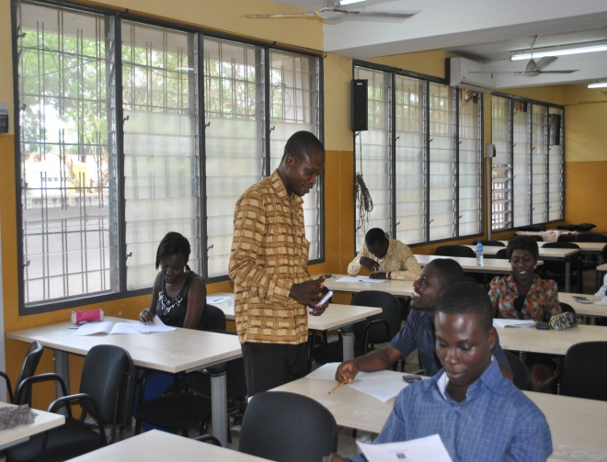Dr. George Domfe, busy at a lecture
His success, he pointed out, is not only career-wise but in terms of family as well. As a married man with 3 children and an aged mother, it was almost unthinkable for him to travel away from his family for more than a few days. “The GGDDS therefore worked perfectly for me as it was possible for me to earn my doctoral degree from a top-of-the-line programme, focus my research on a critical local problem while at it, as well as be there for my family”, he stated.
Dr. Domfe, has research interest in the areas of macroeconomic management of natural resources and the contribution of the emerging capital markets in Africa to economic growth and development. He has a number of publications to his credit including two chapters of his thesis.
In a separate conversation with the Director of ISSER, Prof. Felix Asante said the German Ghanaian Division for Development Studies (GGDDS), founded in 2008, is a collaboration between ISSER, University of Ghana and the Centre for Development Research (ZEF) in Germany and funded by the German Academic Exchange Service (DAAD).
Under the programme, directed at middle and upper level policy makers and development practitioners as well as university graduates with an excellent academic record drawn from Ghana and Africa, five sponsored students are each year admitted after a competitive screening process.
He explained that development of the programme was strategic and based on the premise that:
- We can train the next generation of leaders for Africa, in an African milieu, focusing on African problems while maintaining the global outlook necessary.

- We can train two students for the cost of training one on the same programme in Europe.

- We can reduce the scourge of brain drain by training students locally.
Dr. Charles Ackah, acting coordinator of the PhD programme at ISSER said the programme, which started as a 3-year programme has now been upgraded to 5 years, to allow for 2 years of course work. Teaching is carried out by a large number of lecturers from ISSER, other departments of the University of Ghana and ZEF and this helps give an interdisciplinary perspective to students, he said.
According to Dr. Charles Ackah, students, as part of the training visit Germany, for two months, to give them opportunity to interact with development researchers at the Centre for Development Research (ZEF), review literature, work on thesis proposals, and get international exposure and network.
Describing other aspects of the ISSER PhD programme under the GGDDS, Dr. Ackah said another outstanding quality of the GGDDS consists of supporting African PhD students in their home environment and providing for adequate training and a conducive environment for research.
The GGDDS, based at ISSER, University of Ghana, enrolled its fifth batch of students in April 2014 and has a total student number of 17. Since its inception in 2008, 6 students have successfully graduated from the programme with doctorate degrees in Development Studies.
The Programme coordinator at ZEF is Dr. Wolfram Laube.
More information on the GGDDS is available at http://isser.edu.gh/index.php?option=com_content&view=article&id=58&Itemid=205

The Staff Zone (S-Zone)
Why do Strategic Plan Fail? Tips on what not to do

There is an adage that, “if you fail to plan, you plan to fail.” Strategic planning drives give organizational leaders the chance to define strategy, set direction and make key decisions. It breathes life into the vision and gives the existing motivation a track to run on. But a plan doesn’t inherently ensure success.
Here are major reasons why plans fail. Let’s get informed and be mindful of these traps even as we get ready to launch the next five-year plan at ISSER.

Lack of Buy-In
If the leaders of an organization or department do not think it is important to create a strategic plan – or that it’s a waste of time compared to their normal duties – it’ll be hard for them to invest their full attention and effort into the process. If the organisation’s leaders do not buy in, it is over before it started. It is thus important that leaders first of all buy into both the process and purpose – and then use their influence to convince the rest of the organisation to participate.

Misunderstanding the Difference between a Strategy and a Plan
A strategy is not the same thing as a plan, and a plan is not the same thing as a strategy. The two are different. A strategy is a set of choices that clarify the organization’s competitive advantage, value proposition, target audience and essential capabilities. A plan is an actual list of goals, objectives and tasks that need to be accomplished. A plan becomes “strategic” when it is informed by the strategy. Without a strategy, a plan is simply an organized list of good ideas.

Complicated End Product
Many leaders assume strategic plans need to be completely comprehensive and address every concern and possibility. In some large organizations, higher leadership elements may mandate that strategic plans adhere to a certain format or length. But for the rest, large plans can actually create a disincentive for implementation simply because they are too detailed – especially for leaders who aren’t natural planners. It is possible for a strategic plan to fit on a single page as long as the team disciplines itself to clarify which priorities are most important.

It Never Gets Implemented
This is one of the results of an overly-complicated plan. No one wants to deal with it! Make sure each task has an owner assigned. In addition, make sure the entire plan has an owner – someone who will follow up with the task owners and track the progress. If the chief leader is not the acting owner of the strategic plan, he should appoint (or the other leaders agree on) a “strategic plan czar” who will perform the follow-up duties.

Sticking to “the Plan”
You read that right. Sticking to the plan can actually get in the way of execution effectiveness. At the end of the day, a strategic plan is like a battle plan or a game plan. Once you get into the action, you’ll have to improvise. A strategic plan should be written in pencil. If it’s immune to any changes, your team won’t be able to make the necessary adjustments. Invest in period revisions.

Staffing Requirements not Fully Understood
Resource planning is a crucial part of the project planning process, and, if not carefully implemented, incorrect assumptions and estimates made regarding human resource requirements, including the number, role, skill, and timing perspectives can impact project timeframe and overall bottom line costs. After all, plans depend on the resources who deliver them. Data and information is crucial both at the planning stages, and throughout the project process, to monitor availability and project status, and to make any necessary course corrections.

Unrealistic Goals or lack of focus and resources
Strategic plans must be focused and include a manageable, clearly defined number of goals, objectives, and programs. Adequate resources to accomplish those goals and objectives outlined in the plan must be adequately allocated.

So there, we have it; the success of our strategic plan is in our hands. Let’s us make the time, effort and work we all invested into Koforidua 2014 count.

Strategic Planning Basics, Retrieved May 14, 2014 from:http://balancedscorecard.org/Resources/StrategicPlanningBasics/tabid/459/Default.aspx

The Main Reasons Strategic Planning fails, Retrieved May 14, 2014 from: http://www.nathanmagnuson.com/the-main-reasons-strategic-planning-fails/,
http://blog.tempoplugin.com/2013/7-reasons-why-strategic-plans-fail-and-how-you-can-avoid-them/

And now, some images from the ISSER Strategic Planning Retreat, held in Koforidua, Eastern region of Ghana, from April 25 to 26, 2014, for your viewing pleasure.
Selected pictures from Koforidua 2014

Events
International Gender Analysis Training Workshop in pictures
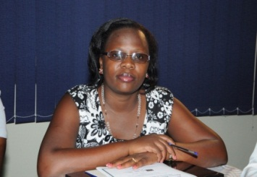
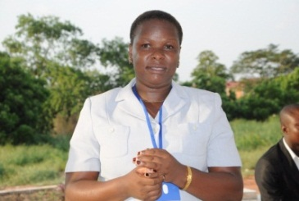
The Institute of Statistical Social and Economic Research (ISSER) in partnership with the Think Tank Initiative (TTI) of the IDRC hosted a five-day International Gender Analysis Training Workshop, from April 7 to 11, 2014, for social science researchers in Sub-Saharan Africa under the theme “engendering social science research.” The workshop brought together twenty (20) social science researchers drawn from over five countries in East, West and Central Africa for five insightful days of learning, knowledge and experiences sharing, as well as practical training on how to successfully incorporate gender in research and the analysis of data.

ISSER, among other objectives, is committed to building capacity to drive the process of development.

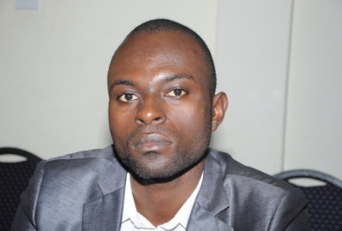
The researcher brings you the workshop in pictures, as well as some participant testimonies. Enjoy!!!

Testimonies from our participants

“Indeed, I have learnt what I did not know. The workshop has empowered me on methods to use for a truly gendered research”. Dorothy Massa, African Institute for Strategic Research Governance and Development, Uganda

“My work is in the area of local government
and political participation. From this point onwards, I have been empowered to work to ensure a gender-based local government output”. Lilian Muyomba-Tamale, ACODE – Advocates Coalition for Development an Environment, Uganda

“I am now better aware of gender
analysis. I have discovered new areas of research. I have also acquired new methods and techniques to evaluate gender-based studies”. Ongono Patrice, University of Yaounde, Cameroon
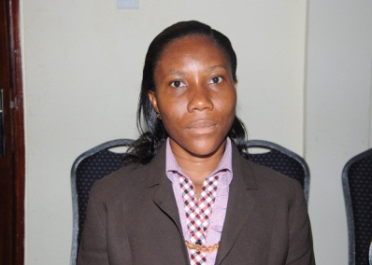
“As a social scientist it is always my desire to understand the social set up and behavior of the people I interact with and to contribute to making a change in solving the problems identified. This workshop has exposed and equipped me with the necessary skills to be able to carry out spot on research to understand the real issues that people are confronted with.” Benedicta Nsiah Frimpong, CRI, Kumasi

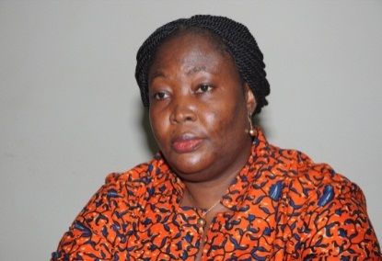
“It will not only impact positively on my research but also on the teaching of my gender and development courses. Knowledge has also been gained from interacting with other participants. The modules provided a clearer understanding of issues particularly with respect to gender statistics and feminist methodologies.” Dr. Mavis Dako-Gyeke, Department of Social Work, UG

Learning Sessions in full gear

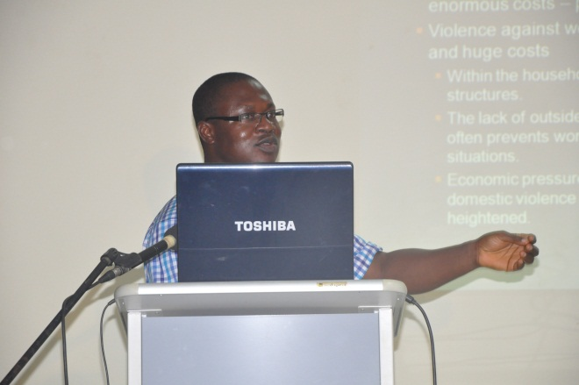

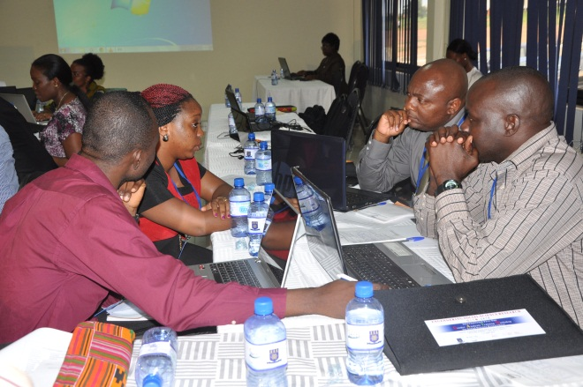
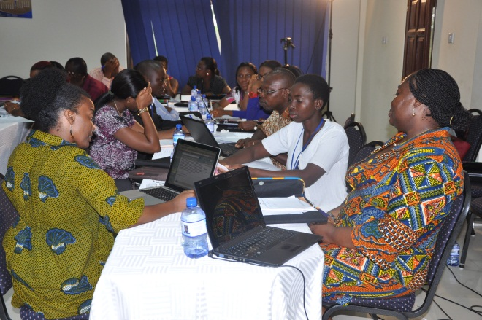

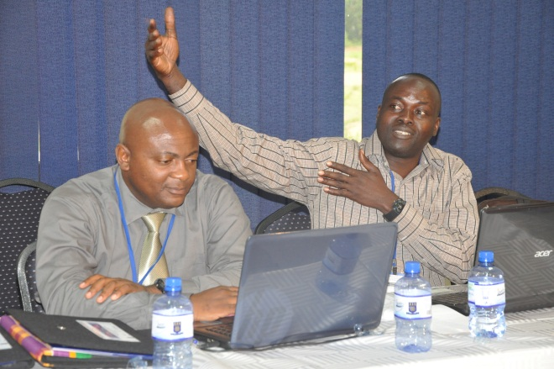
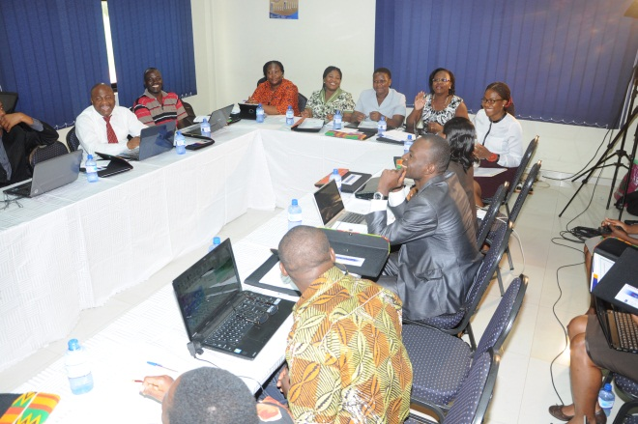
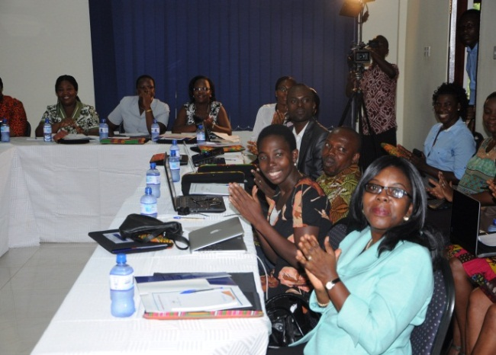

ISSER staff take a break to socialize with participants. Cheers!!
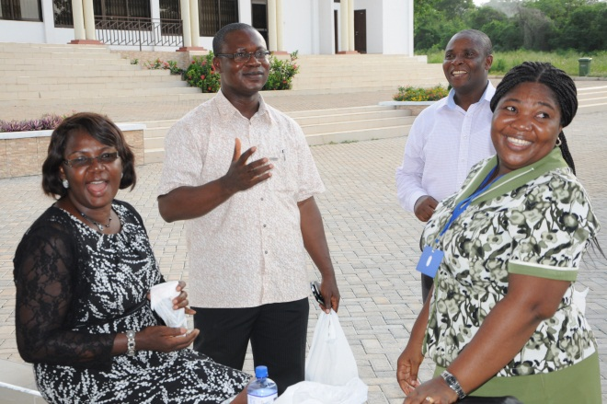
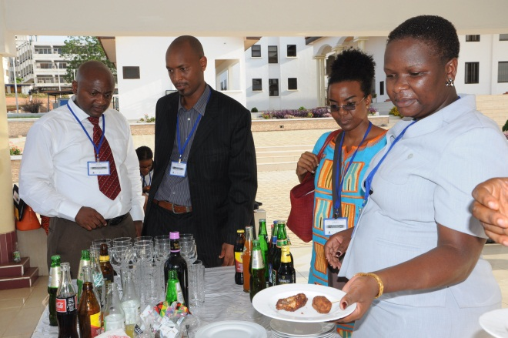
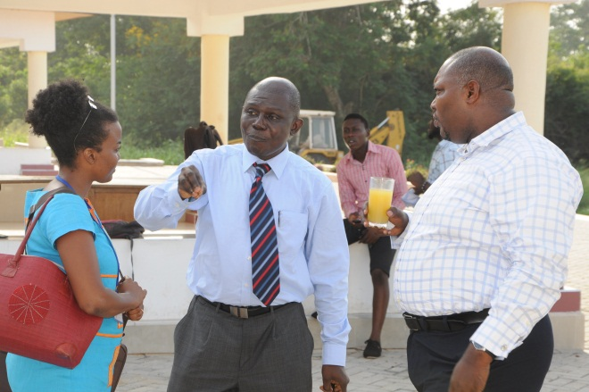
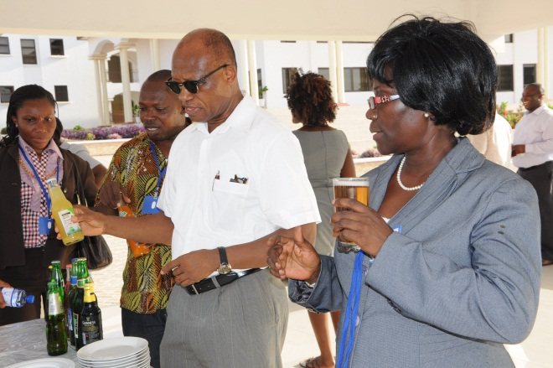
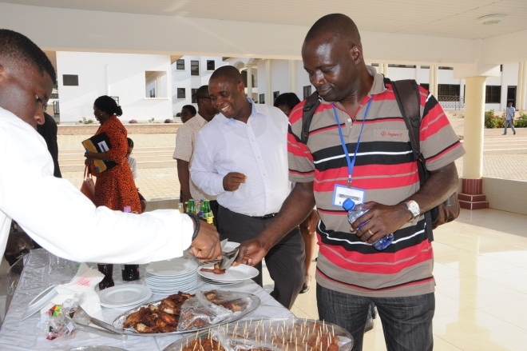

Last Page: About the Institute of Statistical Social and Economic Research (ISSER)
Who we are:
The Institute of Statistical, Social and Economic Research (ISSER) is a semi-autonomous research institution within the Faculty of Social Sciences at the University of Ghana. ISSER is committed to carrying out research and training that promotes the socio-economic development of Ghana and Africa. The Institute strives to maintain its reputation for solid social science research, paying close attention to exploratory, explanatory and evaluative aspects of the dynamics of development. For its advocacy work, ISSER seeks to inform Ghanaian and international development policy makers and practitioners about the socio-economic status of Ghanaians and the opportunities for improvement, using state of the art policy research tools. To contribute towards capacity-building for this process, ISSER also undertakes middle-level training in Statistics and a graduate-level programme in Development Studies.

The Institute of Statistical, Social and Economic Research (ISSER) is a semi-autonomous research institution within the Faculty of Social Sciences at the University of Ghana. ISSER is committed to carrying out research and training that promotes the socio-economic development of Ghana and Africa.

Our Mission: To carry out activities that would promote the socio-economic development of Ghana in particular and Africa in general. Specifically, the Institute is expected to undertake research in the social sciences, and promote human resource development

Our Goal: To be recognised as a centre for comprehensive and sustained research and training in the social sciences.
Our Vision: To be recognised globally for promoting knowledge for development through authoritative policy research, training and advocacy

